Task-02: Employee Management System
Goal:
Develop a web application where admin can perform CRUD operations on employee records with authentication and validation.

Tech Stack :
- Frontend: HTML + CSS + JavaScript (basic)
- Backend: Node.js + Express
- Database: MongoDB
- Authentication: Email + Password (JWT – simple)
Step 1: Install Required Packages
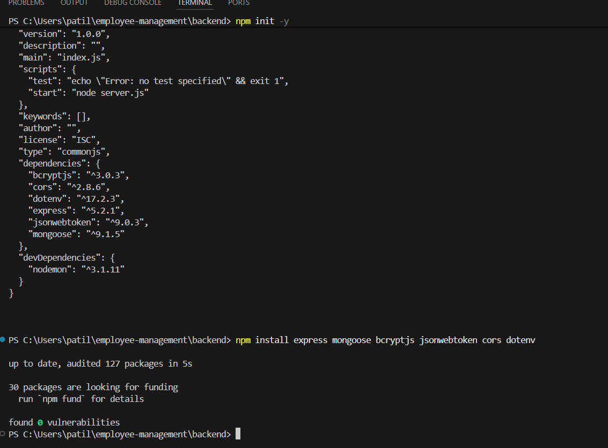

Step 2: Basic Server Setup

server.js
const express = require("express");
const mongoose = require("mongoose");
const cors = require("cors");
require("dotenv").config();

const app = express();

app.use(express.json());
app.use(cors());

mongoose.connect(process.env.MONGO_URL)
.then(() => console.log("MongoDB Connected"))
.catch(err => console.log(err));

app.use("/api/auth", require("./routes/authRoutes"));
app.use("/api/employees", require("./routes/employeeRoutes"));

app.listen(5000, () => {
console.log("Server running on port 5000");
});

Step 3: Admin (Authentication)

models/Admin.js
const express = require("express");
const mongoose = require("mongoose");
const cors = require("cors");
require("dotenv").config();

const app = express();

app.use(express.json());
app.use(cors());

mongoose.connect(process.env.MONGO_URL)
.then(() => console.log("MongoDB Connected"))
.catch(err => console.log(err));

app.use("/api/auth", require("./routes/authRoutes"));
app.use("/api/employees", require("./routes/employeeRoutes"));

app.listen(5000, () => {
console.log("Server running on port 5000");
});

routes/authRoutes.js
const router = require("express").Router();
const Admin = require("../models/Admin");
const bcrypt = require("bcryptjs");
const jwt = require("jsonwebtoken");

router.post("/login", async (req, res) => {
const admin = await Admin.findOne({ email: req.body.email });
if (!admin) return res.status(400).send("Admin not found");

const isMatch = await bcrypt.compare(req.body.password, admin.password);
if (!isMatch) return res.status(400).send("Wrong password");

const token = jwt.sign({ id: admin._id }, "secretkey");
res.json({ token });
});

module.exports = router;

Step 4: Authentication Middleware

middleware/authMiddleware.js
const jwt = require("jsonwebtoken");

module.exports = function(req, res, next) {
const token = req.header("Authorization");
if (!token) return res.status(401).send("Access denied");

try {
const verified = jwt.verify(token, "secretkey");
req.admin = verified;
next();
} catch {
res.status(400).send("Invalid token");
}
};

Step 5: Employee Model

models/Employee.js
const mongoose = require("mongoose");

const employeeSchema = new mongoose.Schema({
name: String,
email: String,
department: String,
salary: Number
});

module.exports = mongoose.model("Employee", employeeSchema);

Step 6: CRUD Operations

routes/employeeRoutes.js
const router = require("express").Router();
const Employee = require("../models/Employee");
const auth = require("../middleware/authMiddleware");

// CREATE
router.post("/", auth, async (req, res) => {
const emp = new Employee(req.body);
await emp.save();
res.send("Employee added");
});

// READ
router.get("/", auth, async (req, res) => {
const employees = await Employee.find();
res.json(employees);
});

// UPDATE
router.put("/:id", auth, async (req, res) => {
await Employee.findByIdAndUpdate(req.params.id, req.body);
res.send("Employee updated");
});

// DELETE
router.delete("/:id", auth, async (req, res) => {
await Employee.findByIdAndDelete(req.params.id);
res.send("Employee deleted");
});

module.exports = router;

step 7: Frontend (Very Simple)

Login.html
<!DOCTYPE html>
<html>
<head>
<title>Admin Login</title>
</head>
<body>

<h2>Admin Login</h2>

<input type="email" id="email" placeholder="Email"><br><br>
<input type="password" id="password" placeholder="Password"><br><br>

<button onclick="login()">Login</button>

<script src="script.js"></script>
</body>
</html>

Script.js
// ---------- LOGIN ----------
function login() {
fetch("http://localhost:5000/api/auth/login", {
method: "POST",
headers: {
"Content-Type": "application/json"
},
body: JSON.stringify({
email: document.getElementById("email").value,
password: document.getElementById("password").value
})
})
.then(res => {
if (!res.ok) {
throw new Error("Login failed");
}
return res.json();
})
.then(data => {
localStorage.setItem("token", data.token);
alert("Login successful");
window.location.href = "dashboard.html";
})
.catch(() => alert("Login failed"));
}

// ---------- DASHBOARD ----------
function goAdd() {
window.location.href = "addEmployee.html";
}

function goView() {
window.location.href = "viewEmployee.html";
}

function goBack() {
window.location.href = "dashboard.html";
}

function logout() {
localStorage.removeItem("token");
window.location.href = "login.html";
}

// ---------- ADD EMPLOYEE ----------
function addEmployee() {
const token = localStorage.getItem("token");

if (!token) {
alert("Please login first");
return;
}

fetch("http://localhost:5000/api/employees", {
method: "POST",
headers: {
"Content-Type": "application/json",
"Authorization": token
},
body: JSON.stringify({
name: document.getElementById("name").value,
email: document.getElementById("email").value,
department: document.getElementById("department").value,
salary: document.getElementById("salary").value
})
})
.then(res => res.text())
.then(msg => {
alert(msg);
window.location.href = "dashboard.html";
})
.catch(err => alert("Error adding employee"));
}

// ---------- VIEW EMPLOYEES ----------
function loadEmployees() {
const token = localStorage.getItem("token");

fetch("http://localhost:5000/api/employees", {
headers: {
"Authorization": token
}
})
.then(res => res.json())
.then(data => {
let html = "";
data.forEach(emp => {
html += `<p>${emp.name} | ${emp.department} | ₹${emp.salary}</p>`;
});
document.getElementById("list").innerHTML = html;
});
}

Step 8: Run the project:

LOGIN:
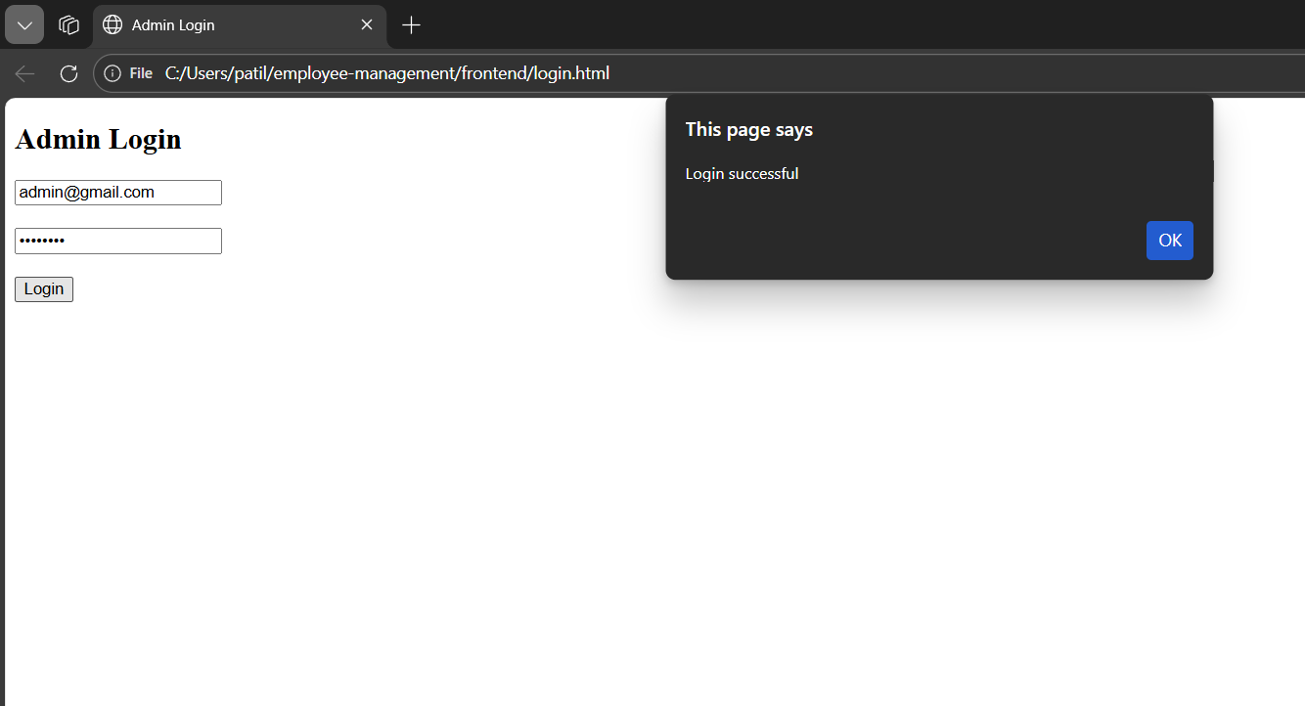

ADD EMPLOYEE:
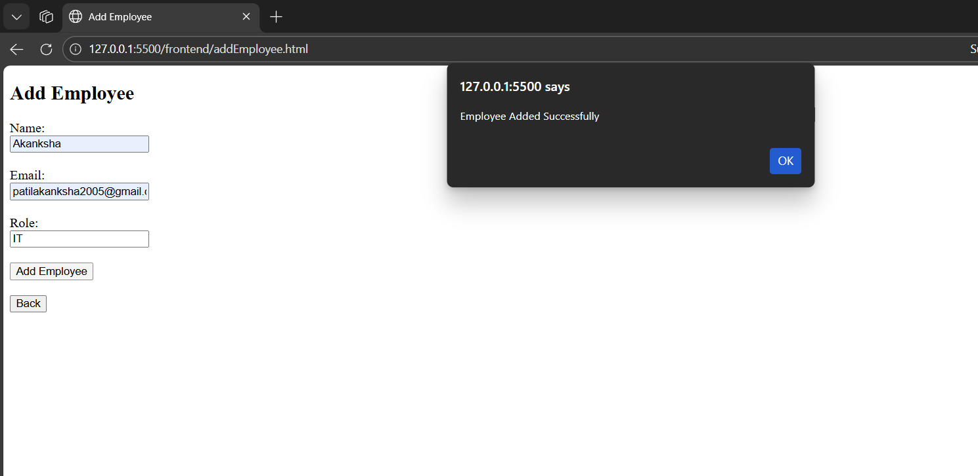

VIEW EMPLOYEE:
